Write a Python Program to Implement Breadth-First Search (BFS)

Aim
To write a Python program to implement the Breadth-First Search (BFS) algorithm for graph traversal.

Objective
To traverse all the nodes of a graph level by level using the Breadth-First Search (BFS) algorithm.

Algorithm
- Start.
- Create a graph using an adjacency list.
- Select the starting node.
- Add the starting node to the queue and mark it as visited.
- Remove a node from the front of the queue.
- Display the node.
- Add all unvisited adjacent nodes to the queue.
- Repeat Steps 5–7 until the queue becomes empty.
- Stop.
FLOW CHART
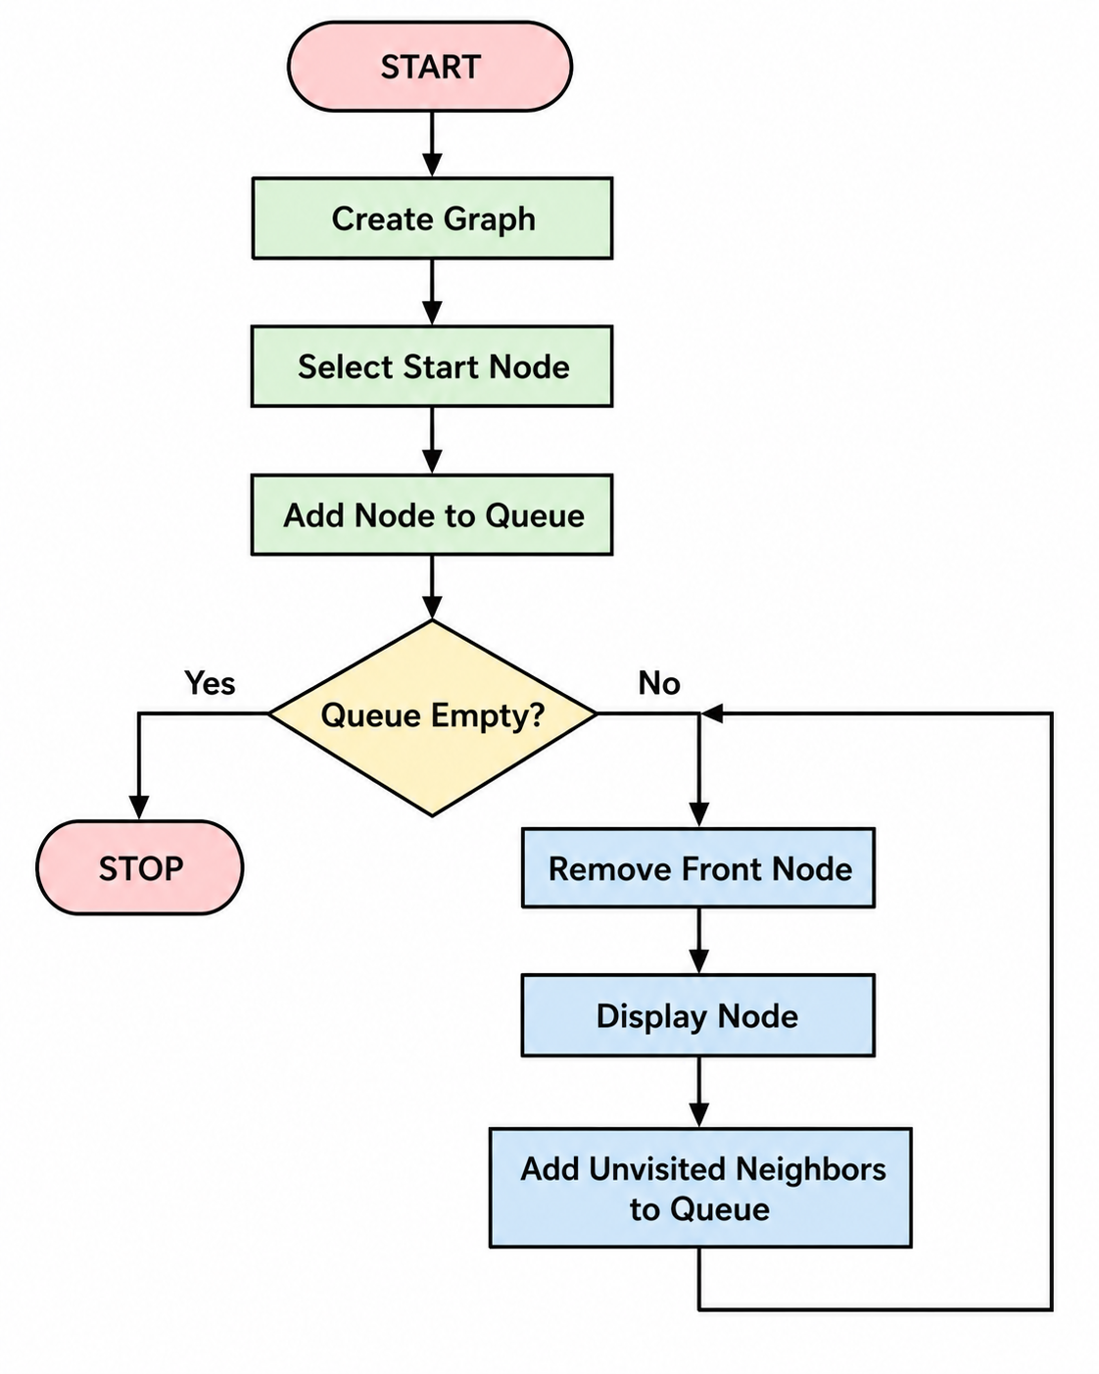

CODE;
from collections import deque

graph = {
'A': ['B', 'C'],
'B': ['D', 'E'],
'C': ['F'],
'D': [],
'E': ['F'],
'F': []
}

visited = set()
queue = deque(['A'])

while queue:
node = queue.popleft()

if node not in visited:
print(node, end=" ")
visited.add(node)

for neighbor in graph[node]:
if neighbor not in visited:
queue.append(neighbor)
OUTPUT:
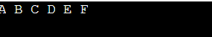

RESULT:
The Python program successfully traversed all the nodes of the graph using the Breadth-First Search (BFS) algorithm.

Conclusion
The Breadth-First Search (BFS) algorithm was successfully implemented in Python. The graph was traversed level by level using a queue, demonstrating an efficient method for graph traversal in Artificial Intelligence.

